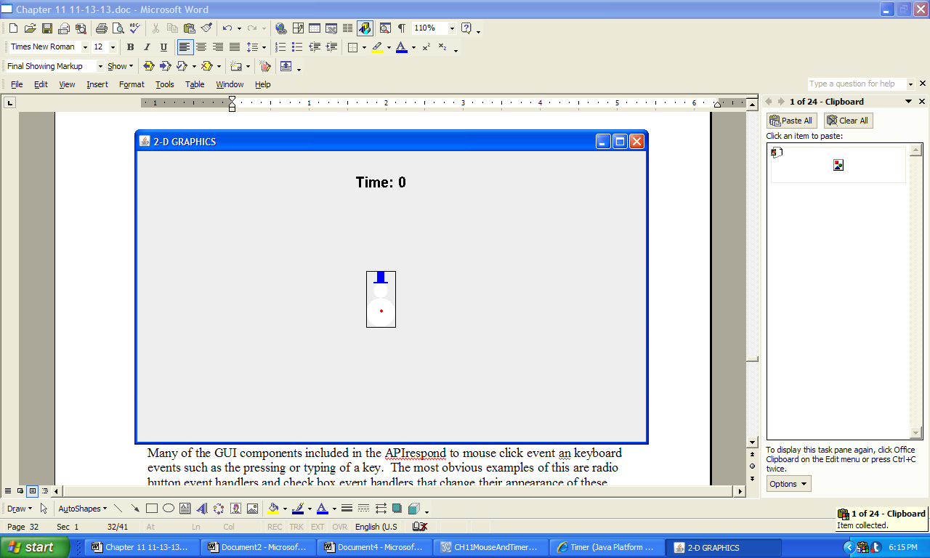

**Figure 11.25 The output produced by the application Graphics2D.**